Report on assessing core body temperature from non-invasive methods

Objectives

The purpose of core body temperature measuring through non-invasive methods is first and foremost to gain an accurate reading of core body temperature. Secondly as invasive methods already exist and can cause users discomfort, it will be a process to create a way to gain information via a non-intrusive method not to cause user discomfort. The idea is to create a low level of intrusion with the high levels of accuracy when measuring core body temperature. The aim is to develop a system that can be done quickly with the option of continuous monitoring of patients. This can yield many benefits in the medical sector with reusable equipment instead of throwing away use sensors and packaging. It will also make primitive technologies such as thermometers or other inaccurate methods of measurement obsolete allowing for a more reliable set of data. There is also the idea of reducing cost in pre-existing temperature gauges, reducing need for access energy output in creating a zero-heat flux zone or reducing the amount of sensors used when measuring core body temperature.

Background

Background to the research undertaken is the changes and need for thermal regulation for all life, necessary to be kept within 33C – 40C. However, the body temperature of humans should stay between 36.5C-37.5C. Outside these boundaries there are serious negative consequences; and may result in loss of appendages, reduced metabolism, cardiac arrest and death. Core body temperature measurement is vital in sustaining human life.

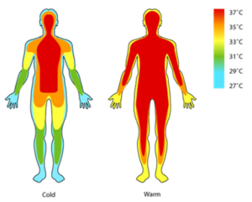**Examples of hypothermia (<32C)**: High mountain climbers experience very reduced temperature many degrees below 0C. This can cause their body temperature to cool down to a dangerous level. In this environment it may be very difficult to measure core body temperature accurately because it may be many degrees above skin temperature. A therapeutic use for hypothermia is it is used in controlled conditions and body temperature is brought down to 32-34C. This is used with patients that have suffered cardiac arrest and during some heart operations, where the patient is cooled to 14-20C.

**Example of hyperthermia(>40C)**: When the body can not correctly or efficiently radiate heat energy to the environment causing core and peripheral temperatures to rise. This can be caused in both therapeutic way or due to a condition or the environment. In a therapeutic setting it is used in cancer therapy, it is the primary way of treating rheumatoid arthritis, arthrosis and migraines. However, it is also caused by non-therapeutic conditions; for example Ebola or Malignant which are both life threating conditions. Hyperthermia is that it causes lots of fluid loss and increases in cardiac output.

**Current Status:**

There are also already sensors that have been created to measure core body. These are high on electricity consumption or costly to produce. They mainly operate by creating a zero heat flux, but this has the cost of using lots of energy and can take time to heat up and to be applied. Pre-existing devices also require four sensors working off the equation:

Tcore = Core temperature

T1, T3 = skin thermistors

T2,T4 = second thermistors

Rs = skin resistance

R1, R2 = thermal resistance

Tcore – T1 T1 -T2

---------------- = ----------

Rs R2

Tcore – T3 T3 - T4

-------------- = ----------

Rs R2

This means the core temperature can be calculated as shown:

(T1-T2)*(T3-T1)

Tcore = T1 + ------------------------

(T1-T2)-(T3-T4)*K

Where k = R1/R2

**Assumptions of model/hypothesis**

When assuming this model I have assumed the sensors will model at 0.1C error from actual temperature. At present this replicates the most accurate sensors on the market.

Other assumptions I have made are: the initial ambient temperature of the room, an estimate of the initial Skin temperature, model parameters of core resistance, material resistance and ambient temperature resistance.

For the device to work effectively it must be able to pick up T1 and T2 at time equals 0 and at time infinity. And it must also be able to calculate the different resistances in the device. With all this combined core temperature should be able to be found.

Analysis

To find core temperature the equation $Tc = T1(RC/R0)(T1 – T2)$

Initial to be able to find Core temperature we we’ll need T1(at time 0), T2(at time 0), T1(at time infinity) and T2(at time infinity)

Showing different resistances:

Skin Padding Sensor to ambient temperature

Tc T1 T2 Ta

Rc R0 Ra

To able to find this

$\frac{Tc-T1}{Rc}=\frac{\left(T1-T2\right)}{R0}=\frac{T2-Ta}{Ra}$

$$\frac{T1\left(0\right)-T2\left(0\right)}{R0}=Tc-\frac{Tc- T1\left(0\right)}{RC}$$

$T2(0) = Ta$ As it hasn’t had a change in temperature immediately

$T1(0) = Tc * R0 + Ta * Ra/R0+Rc$

$T2\left(inf\right)=\left(Ta*Ra\right)+Ta(Rc+R1)/R0+Ra+Rc$

After figuring out how to find core temperature we can now predict what temperature will be at infinity. This is done to reduce time and scans and allows for core body temperature to be predicted after fewer scans:

Knowing what TA is and TInf are and the speed of the growth of the graph (RHO)(temperature against time)

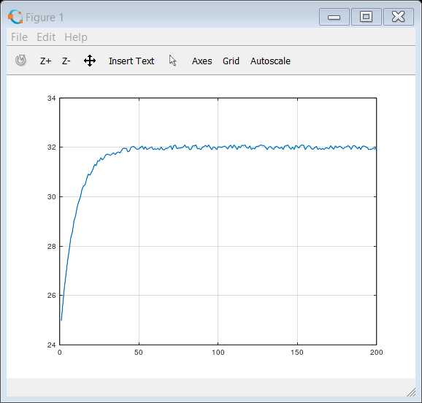

Liner graph of the temperature (temperature against temperature)

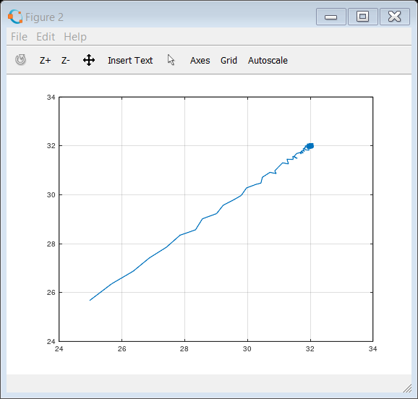 Finding the gradient of the speed of the linear graph based from figure 2

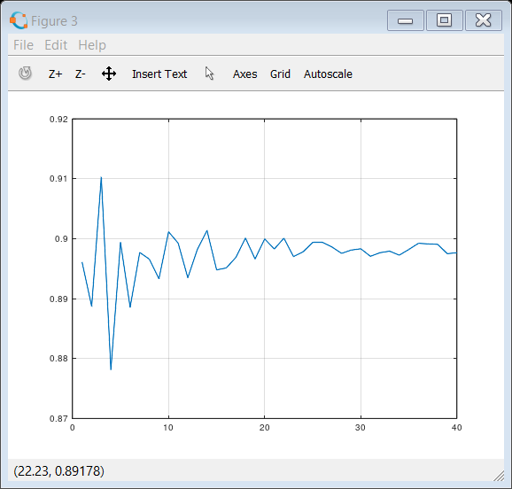

We need this to find the initial value (X2) which is the ambient temperature and the gradient RHO (X1). From this we can predict what T-inf will be:

X1 = Slope

X2 = intercept (1-p)Tinf

$$Tinf = X2/1-X1$$

Software used/developed:

The software that has been used is MATLAB. This is best purposed for graph modelling for calculations.

The heat flow model in figure 1 shows how the temperatures have initially calculated the ambient temperature at rest then the temperature at second 0 (The jump) to then T1 and T2 and time infinity.

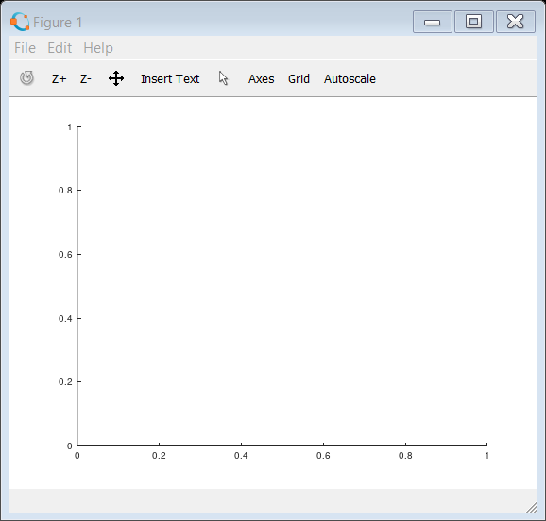

Insert Graph showing the heat rise in T1 and T2 added here

Figure 1

MatLab code written for simulating sensors:

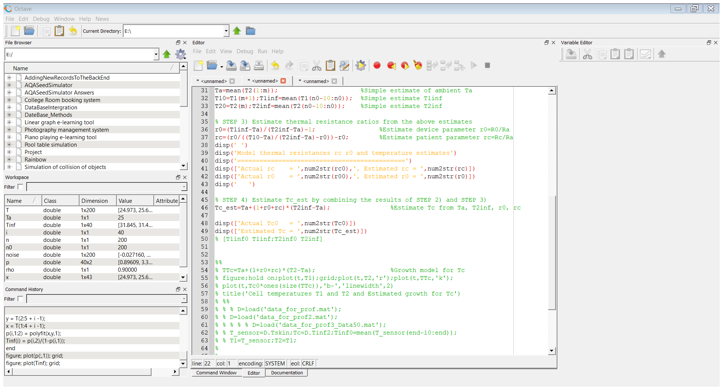

Finding initial values of what T1(0) T2(0)

Tinf1 and Tinf2

Where Tcore is being estimated

Simulations

**Insert figures for graphs Here**

Figure of T1 and T2 temperature change

Graph 1

r0 estimate

rC estimate

Graph 2 – from cell simulation

Tc estimate

display

Graph 3 – from Cell simulation

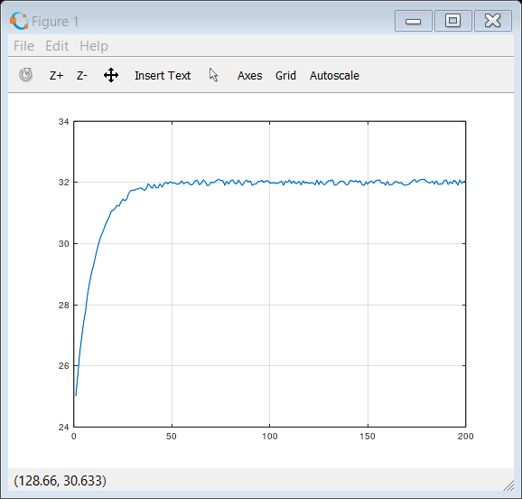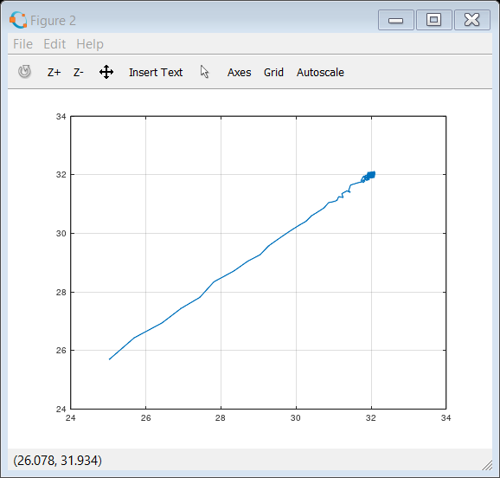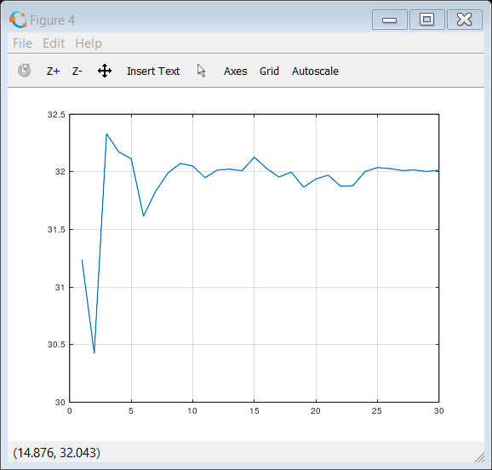Estimate of Tinf after 30 samples :

Results

Finding r0 from (T1inf-Ta)/(T2inf-Ta)-1 to then give rc from (r0/((T10-Ta)/(T2inf-Ta)-r0))-r0 allowed for the four equations to be used as one to find TC = Ta+(1+r0+rc)*(T2inf-Ta);

From this we find our results of the equation needed to find core body temperatre:

Firstly T1(0) T2(0) T1(inf) T2(inf) are needed to be found

$$T1(0) = (Tc*R0+Ta*Rc)/(R0+Rc)$$

$$T2(0) = Ta$$

$$T1(inf) = (Tc*(R0+Ra)+Ta*Rc)/(R0+Ra+Rc)$$

$$T2(inf) = Tc*Ra+Ta*(Rc+R1)/R0+Ra+Rc$$

As there are not enough equations to number of unknowns parts will need to be substituted:

$$r0=R0/Ra$$

$$rC=Rc/Ra$$

$$Tc=Ta+(1+R0+Rc)*(T2inf-Ta)$$

Conclusion

Core body temperature can be estimated from non-invasive sensors. As well as using fewer sensors than previously thought necessary. Instead of using 4 sensors to calculate core ody temperature only 2 are needed.

This is found using the equations of:

$\frac{Tc-T1}{Rc}=\frac{\left(T1-T2\right)}{R0}=\frac{T2-Ta}{Ra}$

$$\frac{T1\left(0\right)-T2\left(0\right)}{R0}=Tc-\frac{Tc- T1\left(0\right)}{RC}$$

$T2(0) = Ta$

$T1(0) = Tc * R0 + Ta * Ra/R0+Rc$

$T2\left(inf\right)=\left(Ta*Ra\right)+Ta(Rc+R1)/R0+Ra+Rc$

$Tc = T1(RC/R0)(T1 – T2)$

A computer programme can be developed to model the differences in core and surface tempertures. The operation of the non-invasive unit will be similar to a pen in look. This will allow for insulation to in between the two sensors and for one to be directly on skin.

Also, Tinf will be predicted at a faster rate. This allows core body temperature to be discerned after fewer scans and with less material input.

References:

Tony Constantinedes – Imperial Collage, London.

Drager – The significance of core body temperature.

Kumar Saurabh, Hiteshwa Rao, Bharadwaj Amrutur, Asokan Sundarrajan (ND) *Continuous core body temperature estimation via surface temperature measurements using wearable sensors* No bibliographic reference.